***PAAREES PERFUMES***

***Christian Diors***

***FOR WOMEN***

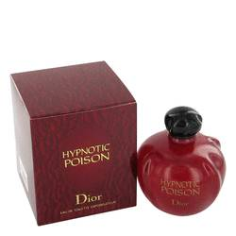

# *Hypnotic Poison*

***Description:***

Hypnotic Poison by Christian Dior Perfume. Cast a seductive spell on everyone you encounter when you wear Hypnotic Poison. Created by the fragrance masters at the Christian Dior design house in 1998, this scent is feminine and sensual. Packaged in a stylish red bottle shaped like a "poisoned apple," the fragrance features an intoxicating mixture of notes, including fruity apricot, coconut, jasmine, rose and soft vanilla. Spray it on before a romantic date to work its magic over the one you desire. Hypnotic Poison is an aphrodisiac for the senses.